**PL/SQL programming (Mandatory hands-on)**

**Exercise 1: Control Structures**

**Scenario 1: Apply discount for customers above 60**

BEGIN

FOR cust IN (SELECT CustomerID FROM Customers WHERE MONTHS_BETWEEN(SYSDATE, DOB)/12 > 60) LOOP

UPDATE Loans

SET InterestRate = InterestRate - 1

WHERE CustomerID = cust.CustomerID;

END LOOP;

END;

/

**Scenario 2: Set VIP flag**

**Assuming we add IsVIP column in Customers:**

**ALTER TABLE Customers ADD IsVIP CHAR(1);**

BEGIN

FOR cust IN (SELECT CustomerID FROM Customers WHERE Balance > 10000) LOOP

UPDATE Customers

SET IsVIP = 'Y'

WHERE CustomerID = cust.CustomerID;

END LOOP;

END;

/

**Scenario 3: Send loan due reminders**

BEGIN

FOR loan_rec IN (

SELECT L.LoanID, C.Name

FROM Loans L

JOIN Customers C ON L.CustomerID = C.CustomerID

WHERE EndDate BETWEEN SYSDATE AND SYSDATE + 30

) LOOP

DBMS_OUTPUT.PUT_LINE('Reminder: Loan ID ' || loan_rec.LoanID || ' for customer ' || loan_rec.Name || ' is due soon.');

END LOOP;

END;

/

**RESULT TABLE:**

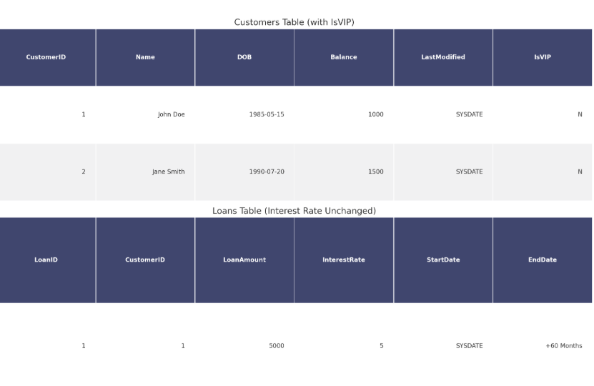

**Exercise 3: Stored Procedures**

**Scenario 1: Process monthly interest**

CREATE OR REPLACE PROCEDURE ProcessMonthlyInterest IS

BEGIN

UPDATE Accounts

SET Balance = Balance + (Balance * 0.01)

WHERE AccountType = 'Savings';

COMMIT;

END;

/

**Scenario 2: Update employee bonus**

CREATE OR REPLACE PROCEDURE UpdateEmployeeBonus(p_dept VARCHAR2, p_bonus_pct NUMBER) IS

BEGIN

UPDATE Employees

SET Salary = Salary + (Salary * p_bonus_pct / 100)

WHERE Department = p_dept;

COMMIT;

END;

/

**Scenario 3: Transfer funds**

CREATE OR REPLACE PROCEDURE TransferFunds(p_from NUMBER, p_to NUMBER, p_amt NUMBER) IS

bal NUMBER;

BEGIN

SELECT Balance INTO bal FROM Accounts WHERE AccountID = p_from FOR UPDATE;

IF bal >= p_amt THEN

UPDATE Accounts SET Balance = Balance - p_amt WHERE AccountID = p_from;

UPDATE Accounts SET Balance = Balance + p_amt WHERE AccountID = p_to;

COMMIT;

ELSE

RAISE_APPLICATION_ERROR(-20002, 'Insufficient balance.');

END IF;

EXCEPTION

WHEN OTHERS THEN

DBMS_OUTPUT.PUT_LINE('Error: ' || SQLERRM);

ROLLBACK;

END;

/

**RESULT TABLE:**

